

**Master The Possibilities, Inc.**

**8415 SW 80th Street Suite 2 Ocala, FL 34481 (352) 861-9751**

**Registrar@masterthepossibilities.org**



**Award Winning Author DL HAVLIN Presents**

**July 18, 2019**

**10:30 to 11:30 AM**

**Tips for the Writer: Novice or Old Hand**

**“I’ve met the enemy and he is me”**

An assemblage of tips … and mistakes to avoid … for all writers. Whether the participant is a new-bee or an experienced author these are suggestions that make your work readable, credible, enjoyable and saleable!

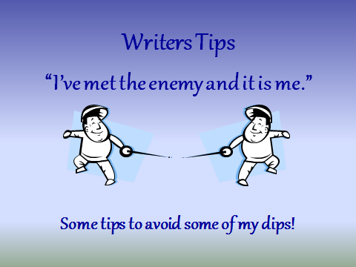

**Flaming Florida I**

**The Land of Perpetual War**

**(1492 to 1808)**

A frontier that was a constant scene of border raiders, slave chasers, militia reprisals, Indian raids and war. Florida was a land painted crimson by the blood and flames that raced over it for more than three centuries. It was one of history’s most violent venues.

From before the days the Spanish stepped ashore on Florida’s sands, violence and war were a way of life. This presentation provides information about Florida’s inhabitants, their culture, and what happened to them.

**1:00 to 2:00 PM**

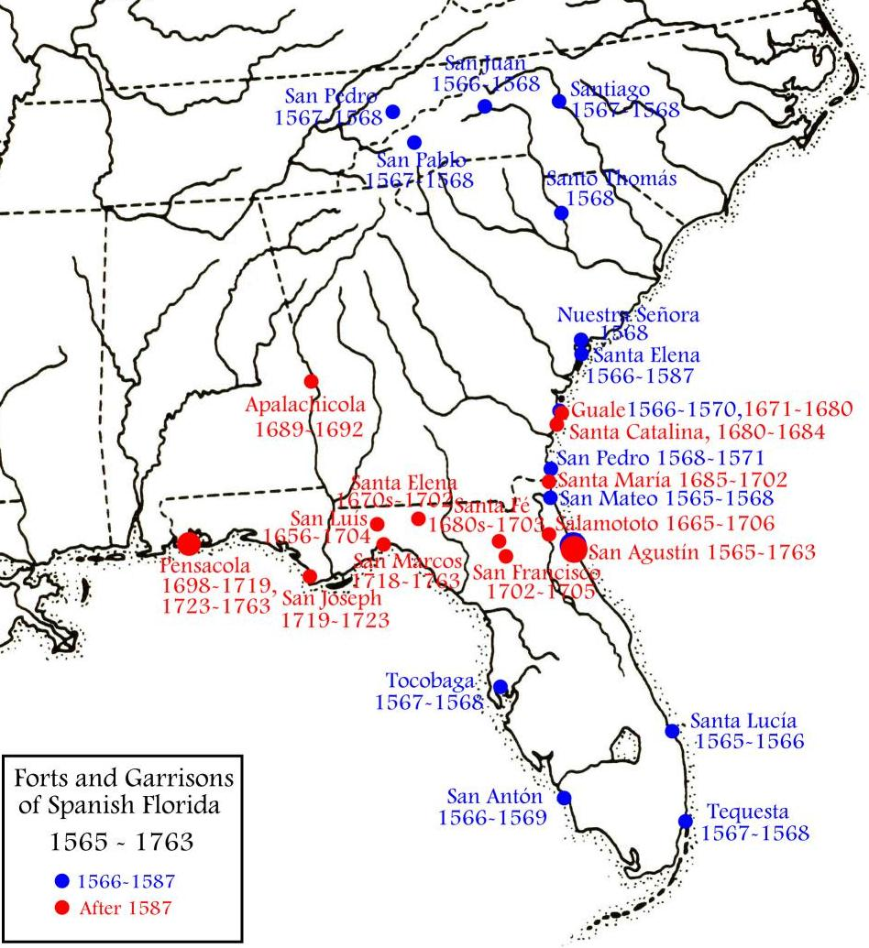

**2:30 to 3:30 PM**

**A look at Hell**

The story of the invasion of Ukraine as related by two men that lived it.

Based on eye witness input, and extensive research, this is the story of two of the world’s most barbarous society’s war on a region and its defenseless people. The population of Ukraine on June 22nd 1941, the day Hitler launched Barbarrosa … his plan to destroy the USSR, exceeded 40 million people. On May 8th 1945, there were 29 million Ukrainians left alive. For ***every day*** of the war over 7,500 innocent people died. It is difficult to tell whether Hitler or Stalin killed more. This is fact, not story.

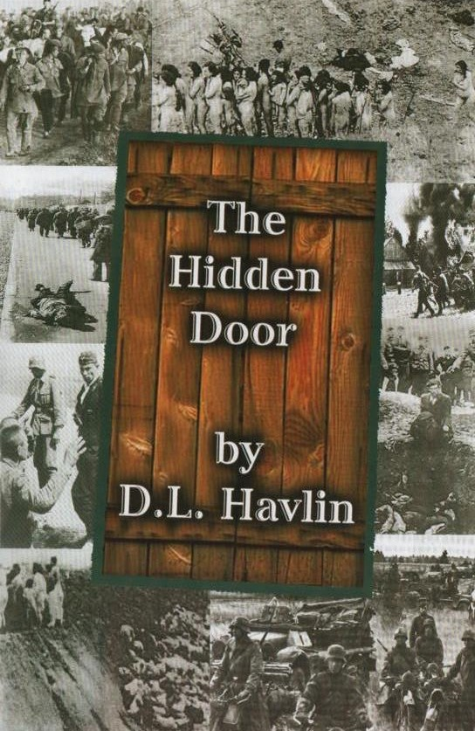

**Award Winning Author DL Havlin**

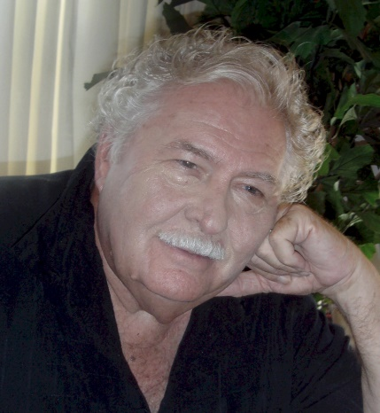

**Educational Background:** College – University of Cincinnati, BBA / Rollins College

**Professional Background –** systems analyst and procedure writer, production manager, materials manager, installed first computer based inventory system for a major manufacturer, product line manager, manufacturing plant manager, general manager of a chemicals distributor, call center service rep, president and general manager of a small manufacturing company, world-wide divisional customer service director, newspaper sports reporter.

**Life Experiences –** high school football coach, licensed boat captain, extensive world travels, fishing guide, avid hunter and camper, amateur historian studying early Florida, Civil War and World War II, former regional director for the Florida Writers Association, Board member ABC Writers - Have been writing 30+ years. - Highly regarded speaker, lecturer and historian.

 