**DL Havlin’s History & Mystery**

**Newsletter – April, 20, 2021**

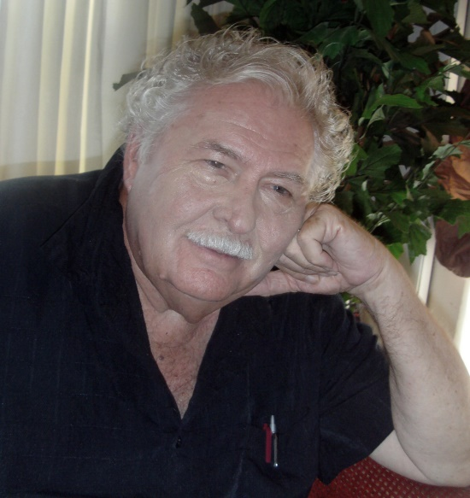

**Updating information about author DL Havlin**

**This Quarter’s Feature**

Hopefully this year will see the social carnage created by covid-19 fade and die. The damage that was done had multiple levels. The obvious…people dying from the laboratory designed virus. Our older population, of which I am a part, suffered disproportionally. Thank goodness for the rapid development of the vaccine and its distribution. The crippling of our social institutions is a second major level. Cancelling social gatherings even to family assembly has crushed our ability to maintain and protect our normal life processes. It has materially helped those who wish us to believe social control is social justice. Our children pay the price as some (certainly not all) teachers would prefer “vacation” to educating our youth. A third level is the obscene use of the pandemic for political purposes. Each time I think the slime in Washington has found a way to reach its lowest competence, ethics, and filthy corruption…it finds ways to sink to new lows. Is there an end. To the direct effects of the virus? Yes. To the damage done to social institutions, our children, the political system. Not visible. It may take years, if ever, to recover. One only has to look at what was once our great news/media. It has reduced itself to irrelevancy.

Covid-19 symptom-

A lot of empty rooms

Where DL has been - The last quarter in review

The Last quarter was impacted by the Covid-19 virus. A third of my appearances were canceled or postponed. The picture to the left was taken at the Kings Gate Community Center in Charlotte County and it occurred after the vaccine began to be distributed. Forty-seven attended. I spoke at the Fort Myers Beach Library, the Cultural Center of Charlotte County, was at Mixon’s, The Book Nook, Books and Such for signings, presented at Gulf Coast Writers, and made three presentations at Master the Possibilities. I’m continuing to make my class presentations virtual at the same time I’m speaking in person. Check my webpage for info.

What’s New

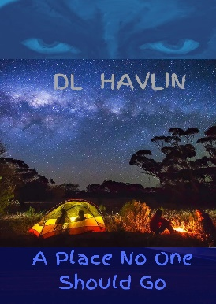

My most recent publication (from PalmPen Press) will be the 3nd edition of ***A Place No One Should Go***. This history/mystery is based on the spiritual beliefs of the Calusa Indians, the dominant tribe of Native Americans in south Florida when the Spanish first arrived. The book is a true mystery suspense. The novella’s story takes place in the everglades on tribal land. A man, Ben Callison, with many personal issues, takes his family on a canoe/camping trip and finds he must cope with an evil 500 years old. Is the force that stalks him real or in his mind? The decisions he makes will impact his family and his life. Indiscretions from his past haunt him as he struggles to survive ***A Place No One Should Go***. (Cover not final)

What’s Coming

One by product of the Corona Virus was to provide me with a lot more writing time than I normally have. I’ve been busy. My great agents at the Seymour Literary Agency have found homes for my Sly Harrell mystery novels…the first three of the ‘Finder’ series. They star Slydell (‘Sly’) Harrell as a Florida Cracker turned recovery specialist. The novels are ***The Grave with Greener Grass,*** ***Finding the Nancy Lynn,*** and ***The Quest for the Calusa Queen***. These are the first three books in the series, with six more to come. The publisher has indicated he is interested in all of them. The virus has slowed everything to a crawl. I’m working on a project I’m very excited about. It’s a WWII ‘near-history’ novel like, ***Blue Water, Red Blood***.

Pics of the Quarter

Where DL will be - Appearances, signings, & other events this quarter: Click Here!

Have you heard?

The Covid-19 virus has added major uncertainty to schedules for all kinds of gatherings. That is very true of my appearances at book events, historical presentations, and meet and greets. For this reason PLEASE use the link above to get the latest and most accurate information on my schedule!

How to:

Buy a book direct from DL Havlin: (all links)

Buy a book on line: (all links)

Buy a book from your local bookstore: (all links)

Arrange for DL Havlin to speak to your group: (all links)

Arrange for DL Havlin to attend your conference, event, or teach a seminar class: (all links)

How to contact DL Havlin’s Literary Agent: (all links)

How to contact DL Havlin’s publicist: (all links)

**Visit** [**www.dlhavlin.com**](http://www.dlhavlin.com) **for more information about DL Havlin and his books**